Annex 1. Anatomical Sketches
The legend for the anatomical sketches contained in Annex 1 is set out below.*

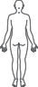
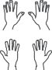
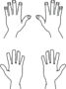
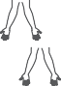
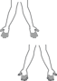
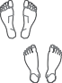
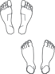
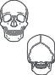
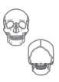
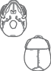
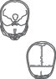
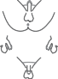
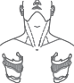

(xix) Neck – Section (R & L) (xx) Spine – three sections 22
33

44

55
S1S1 22
33
44
55
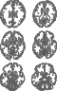
Coc1

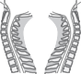
(xxi) Brain – surfaces
22
22
T3T3
T3T3
(i) Whole body – front | (ii) | Whole body – back
(iii) Whole body – side (R) | (iv) | Whole body – side (L)
RR  (v) Head – front and back | (vi) | Head – side (L & R) | LL  LL
(vii) Hands – back and palm (L & R)  LL RR | (viii) | Forearms – (R & L) | RR LL  LL | RR  RR
LL RR  (ix) Feet – soles and dorsum (R & L)  RR LL | (x) | Whole body skeleton
LL RR  (xi) Skull – front and back | (xii) | Skull – side (L & R) | LL
(xiii) Skull – base and top | (xiv) | Skull – inside | RR
(xv) Genitalia – male** | (xvi) | Genitalia – female**
(xvii) Extended neck – front and larynx | (xviii) | Extended neck – side (L & R)
1 1 |  |  | C1C1 i  22  33 | C1C1 22  33
33 33  44 44  55 5  66 66  77 77  T1T1 T1T1  T2T2 T2T2 |  | 22  3  4  55  6  7  T1  T2  T3 | 22 Ti  33  ii  44  55  iv  66  77  88  99 viii  1010  1111  1212  L1L1  22  33 xii  44 | 88  T1T1 22  33  44  55  66  77  88  99  1010  1111  1212

(xxiii) Brain – coronal slices

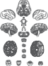
CC
LL RR
SS
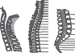
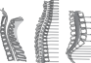
midbrain pons low pons medulla
44 44
55
55
66 44
77 66 55 Li
S1S1
88 77 22 L1L1
33
1
44
T1T1
55
iiii
iii
iviv
(xxii) Brain – slices

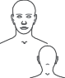
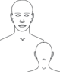
VII. Annex 1

LL RR LL RR LL RR LL RR

* The copyright for the sketches and other annexes is held by the Victorian Institute of Forensic Medicine in Australia, which has kindly agreed to their reproduction in the Protocol. The contribution of the Institute’s Deputy Director, David Ranson, is also gratefully acknowledged.
** Trans people who have had genital surgery, and intersex people with certain sex characteristic variations, will often have genitals that are not easily categorized into male or female genitalia. The examiner should accurately depict the bodies of trans and intersex persons that do not match typical male or female diagrams.

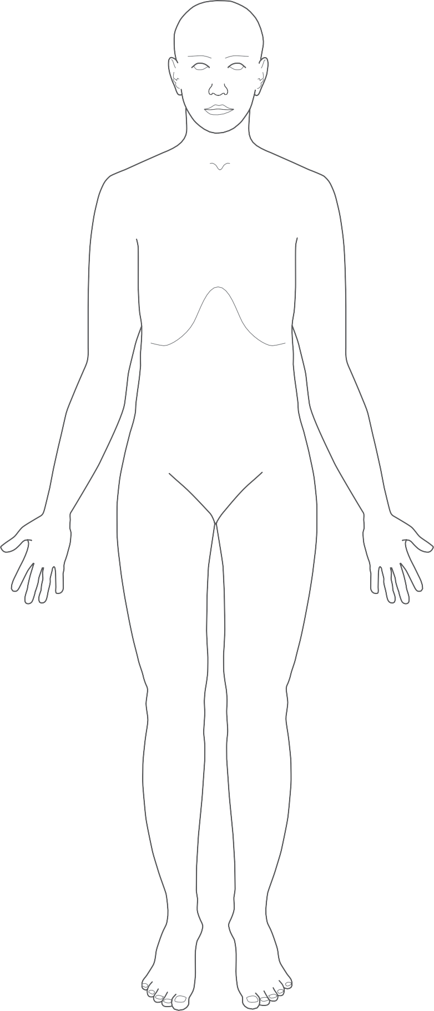
Figure (i)
Whole body – front

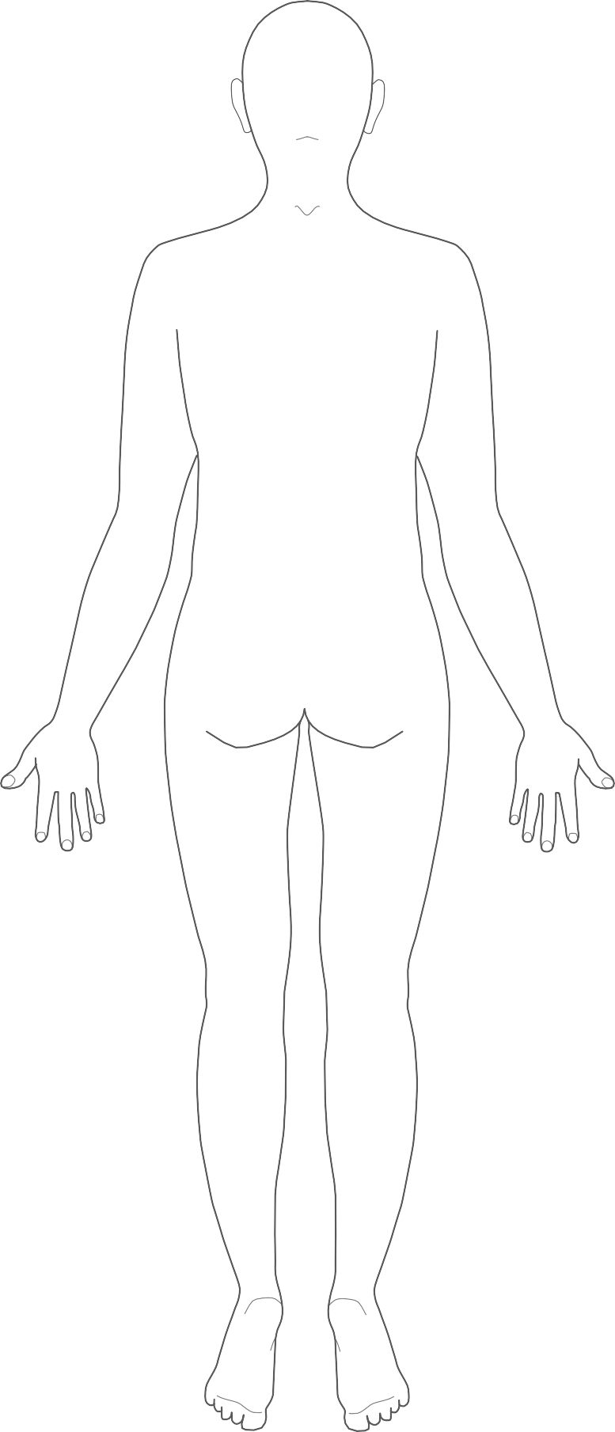
Figure (ii)
Whole body – back

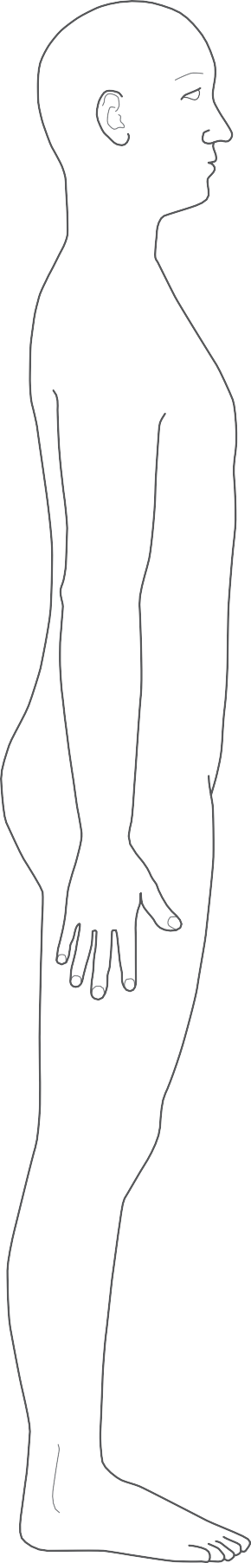
Figure (iii)
Whole body – side (R)

R

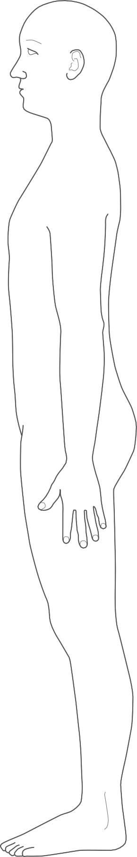
Figure (iv)
Whole body – side (L)

L

Figure (v)
Head – front and back

Figure (vi)
Head – side (L & R)

L
R

Figure (vii)
Hands – Back and Palm (L & R)

L R

L R

Figure (viii)
Forearms – (R & L)
R L

L R

Figure (ix)
Feet – Soles and Dorsum (R & L)

R
L

L
R

Figure (x)
Whole Body Skeleton
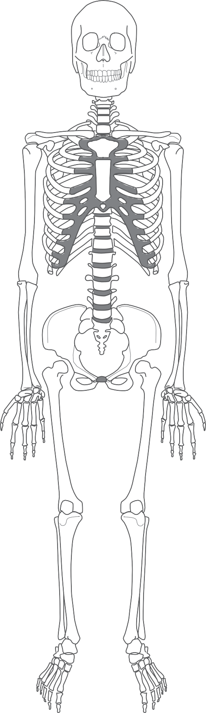

Figure (xi)
Skull – Front and Back

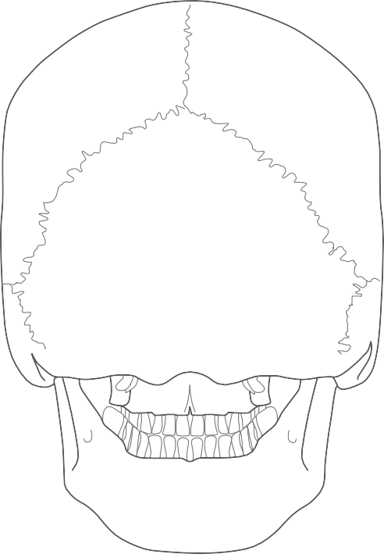
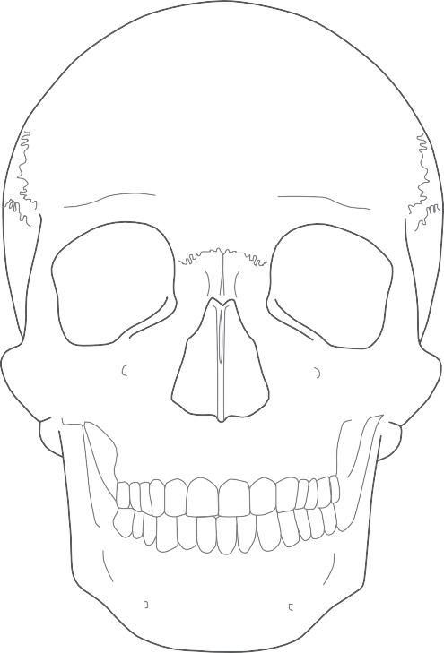

Figure (xii)
Skull – Side (L & R)

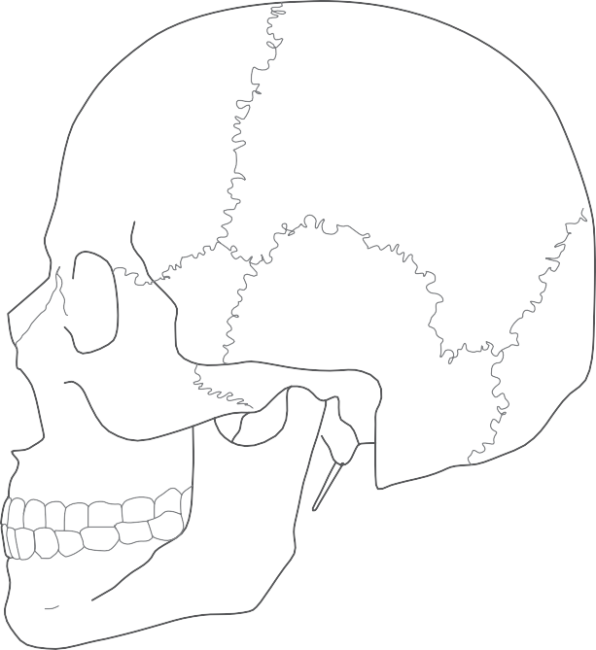
L

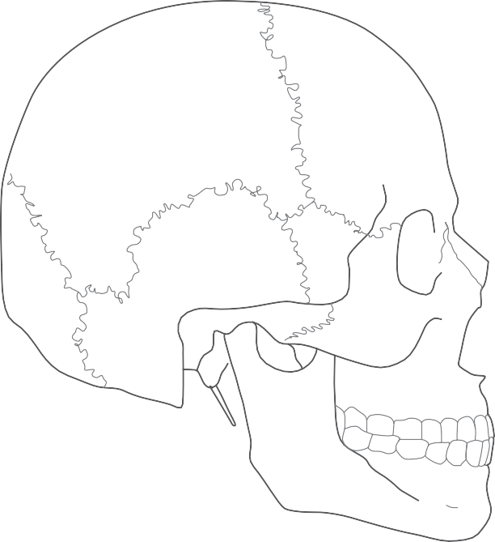
R

Figure (xiii)
Skull – Base and Top

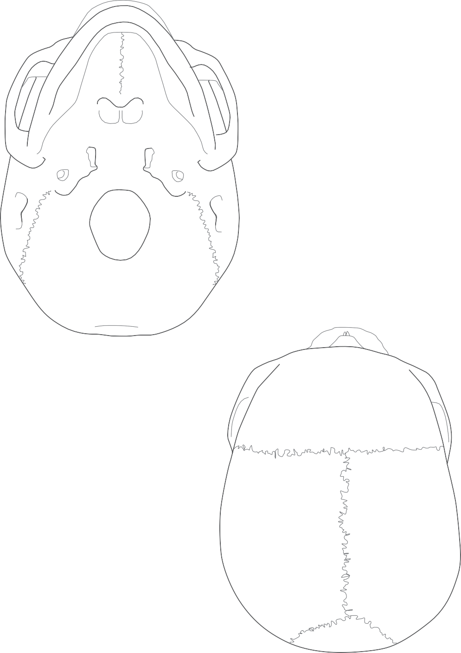

Figure (xiv)
Skull – Inside

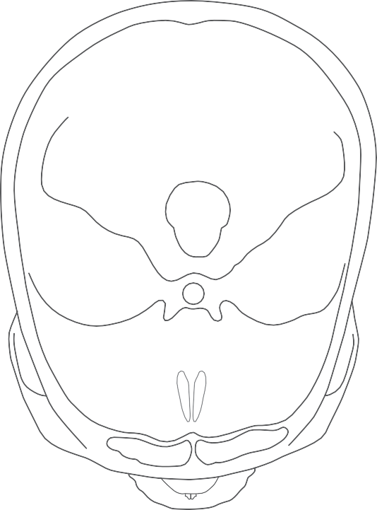
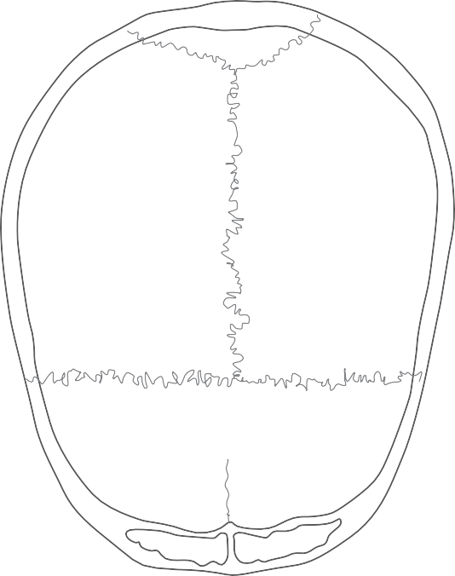

Figure (xv)
Genitalia – Male

Figure (xvi)
Genitalia – Female

Figure (xvii)
Extended Neck – Front and Larynx

Figure (xviii)
Extended Neck – Side (L & R)

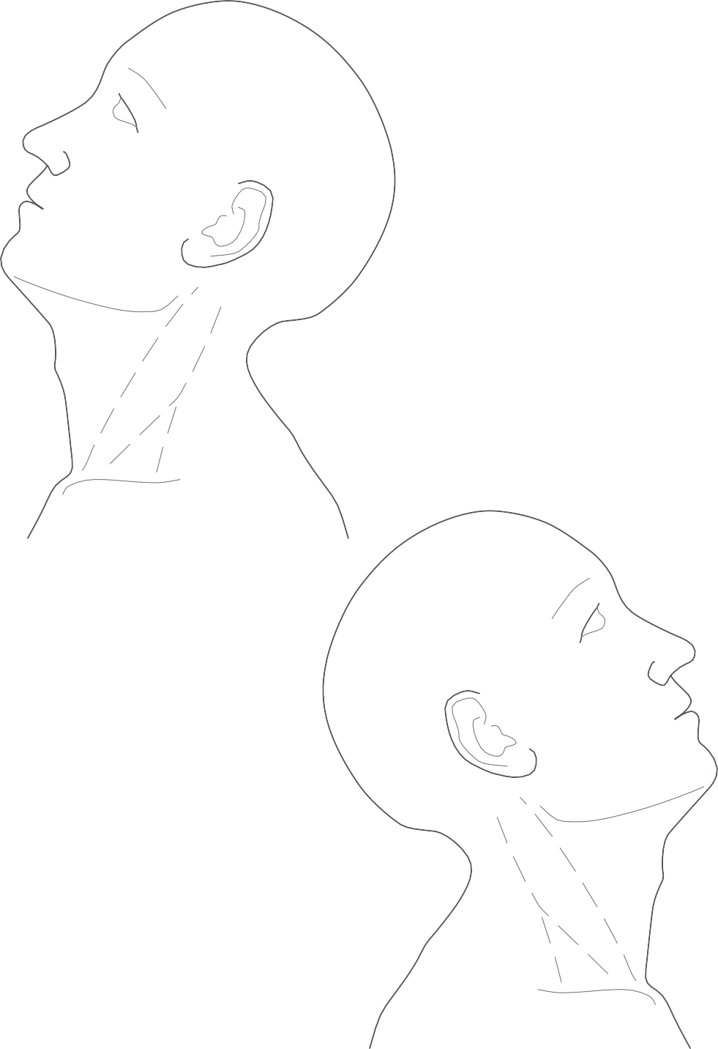
L
R

Figure (xix)
Neck – Section (R & L)

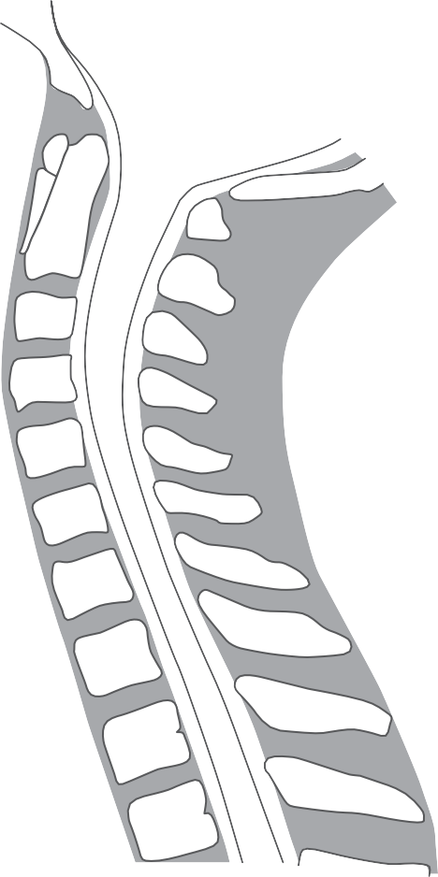
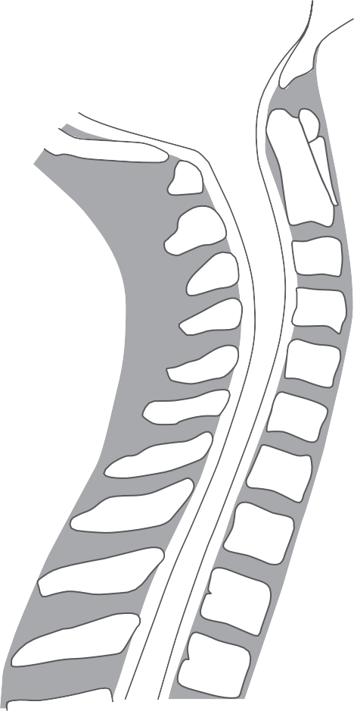
1
2
3

4
5
6
7
T1
T2
T3
1
2
3

4
5
6
7
T1
T2
T3
R L

Figure (xx)
Spine – Three Sections

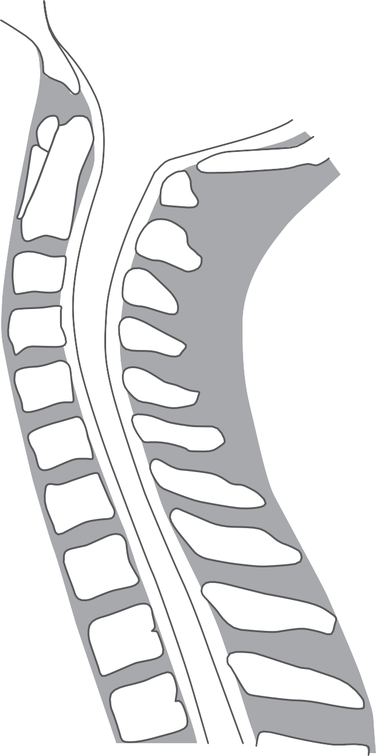
1
2
3
4
5
6
7
T1
T2
T3

Figure (xx)
Spine – Three Sections continued

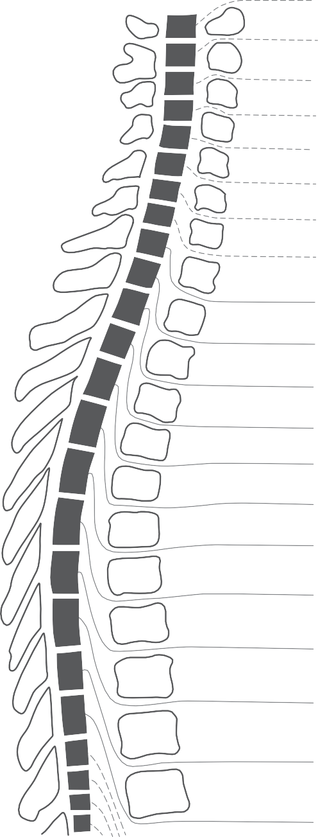
C1 2
i
C1
i
ii
iii
2
ii
3
iii
4
iv
5
v
vi
6
iv
v
7
vi
8
vii
T1
vii
Ti
2
Ti
3
ii
ii
4
iii
iii
5
iv
iv
6
v
v
7
vi
vi
8
vii
vii
9
viii
viii 10
ix
ix 11
x
x
12
xi
L1
xi
2
3
4
xii
3
4
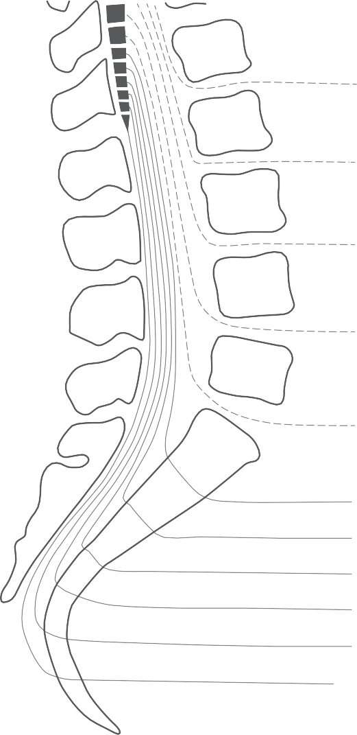
5
6 xii

7
8 Li
T1 ii

2

3

4

4
5
S1 2
3
4
5

iii

Li
L1
ii
2
iii
3
iv

iv
5
6 v v
7
8
9
10

11

12
4

5

S1 2
3
4
5
Coc1

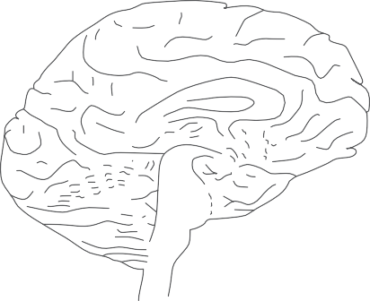
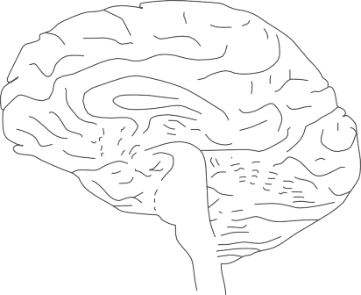
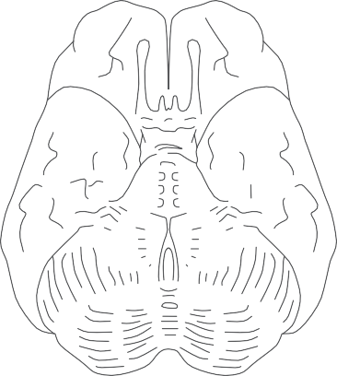
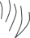
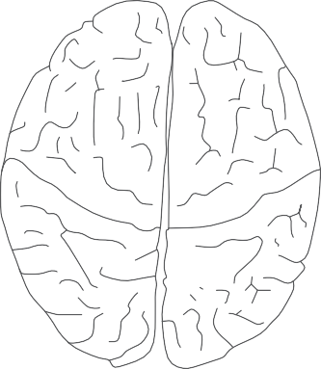
Figure (xxi) Brain – Surfaces

C
T

L

L R
S
midbrain pons low pons medulla

Figure (xxii)
Brain – Slices

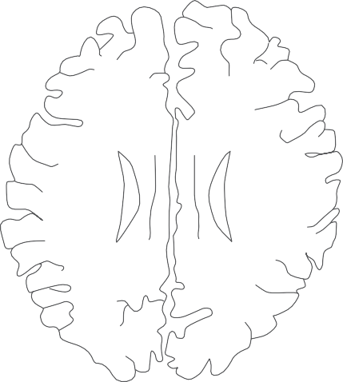
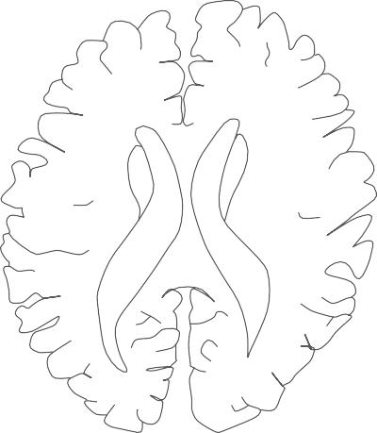
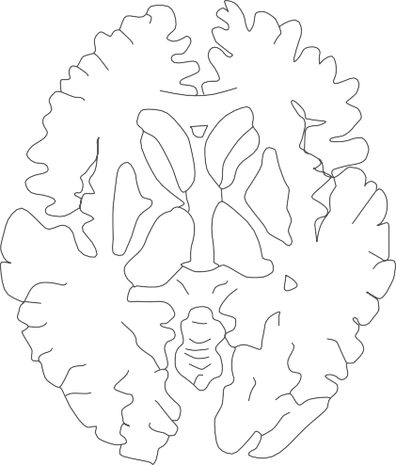
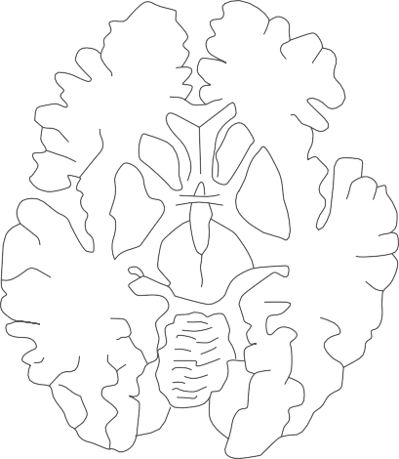
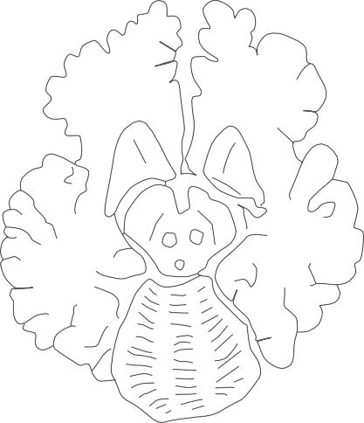
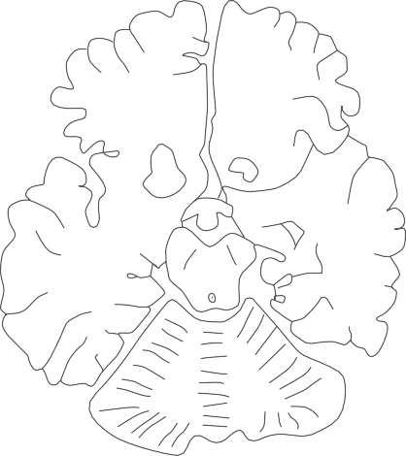

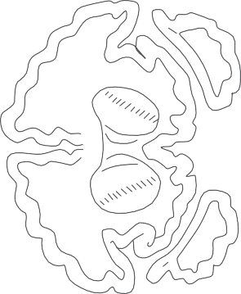
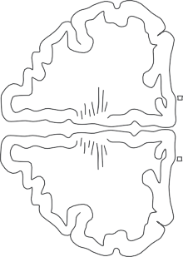
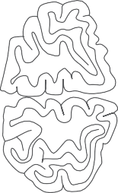
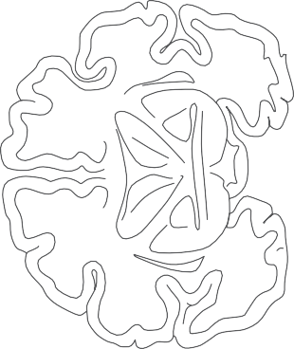
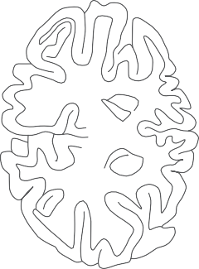
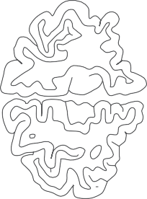
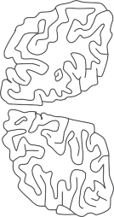
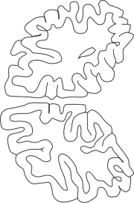
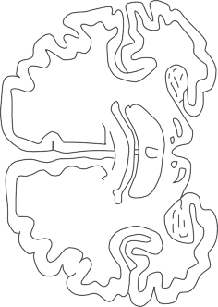
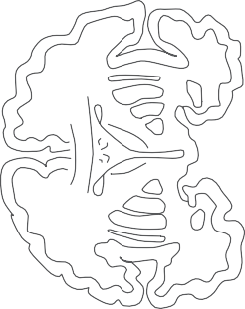
Figure (xxiii)
L
R
L
L
R
L
R
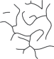
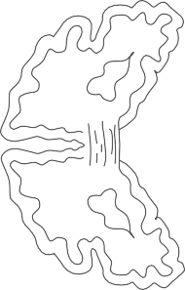
Brain – Coronal Slice
R

